**Semantic Web**

**How to Use HTML Elements Properly?**

**Table of Contents**

* [Web Page](https://github.com/TelerikAcademy/HTML/tree/master/Topics/05.%20Semantic-HTML#/webpage)
  + [HTML, CSS and JavaScript](https://github.com/TelerikAcademy/HTML/tree/master/Topics/05.%20Semantic-HTML#/html)
* [The Semantic HTML](https://github.com/TelerikAcademy/HTML/tree/master/Topics/05.%20Semantic-HTML#/semantic)
* [HTML5 Semantic Tags](https://github.com/TelerikAcademy/HTML/tree/master/Topics/05.%20Semantic-HTML#/html5)
* [Other Semantics](https://github.com/TelerikAcademy/HTML/tree/master/Topics/05.%20Semantic-HTML#/other)
* [Accessibility](https://github.com/TelerikAcademy/HTML/tree/master/Topics/05.%20Semantic-HTML#/access)
* [Search Engine Optimization](https://github.com/TelerikAcademy/HTML/tree/master/Topics/05.%20Semantic-HTML#/seo)
* [Structured Data Markup](https://github.com/TelerikAcademy/HTML/tree/master/Topics/05.%20Semantic-HTML#/datamarkup)

**The Elements of a Web Page**

* A Web page consists of:
  + HTML markup
  + CSS rules
  + JavaScript code
    - JS libraries
  + Images
  + Other resources
    - Fonts, audio, video, Flash, Silverlight, etc…

**The Elements of a Web Page: HTML Markup**

* The HTML is used to define  
  the **content** of a Web page
  + Not the layout
  + Not the decorations
* HTML's role is to present the information in a **meaningful** manner
  + Like a paper document
  + Define headers, paragraphs, text boxes, etc…
  + Not define size, color and/or positioning

**The Elements of a Web Page: CSS Rules**

* Cascading Style Sheets (**CSS**) is the way to make a Web page look pretty
  + Define **styling rules**
    - Fonts, colors, positioning, etc.
  + Define the layout of the elements
  + Define the presentation
* The CSS files are attached to a web page and the browser applies these styles to elements

**The Elements of a Web Page: JavaScript Code**

* **JavaScript** is the programming language for the Web
  + Makes the Web pages dynamic
  + Dynamically adding / removing HTML elements, applying styles, etc.
  + Modern JavaScript UI libraries provide UI components like dialog boxes, grids, tabs, etc.
* Like CSS the JavaScript files are attached to a web page

**The Elements of a Web Page: Other Resources**

* Other resources are needed for a Web page to run properly
  + Images, fonts (glyph icons), audio, video files
  + Flash / Silverlight / ActiveX objects

**Semantic HTML**

* **Semantic** HTML is:
  + The use of HTML markup to reinforce the semantics of the information in Web pages
    - Make the content understandable for computers
  + Rather than merely to define its presentation
  + A kind of **metadata** about the HTML content
* Semantic HTML is processed by regular Web browsers and other user agents
  + CSS is used to suggest its presentation to human users

**Why Use Semantic HTML?**

* Semantic HTML is:
  + Easier to read by developers, parsers, bots, machines, AIs
  + A way to show the search engines the correct content

**How To Write Semantic HTML?**

* Just follow some guidelines when creating a Web site
  + Use HTML5 semantic tags
    - <header>, <nav>, <section>, <article>, <aside>, <footer>
  + Use Headings when you need to structure the content into sub-headings
    - In increasing order, staring with <h1>
  + Do not use empty tags
    - Like a clearing <div>

**HTML5 Semantic Tags**

* HTML5 introduces **semantic structure tags**
  + Imagine the following site:
  + This is a common Web page structure
    - Used in 90% of the web sites

[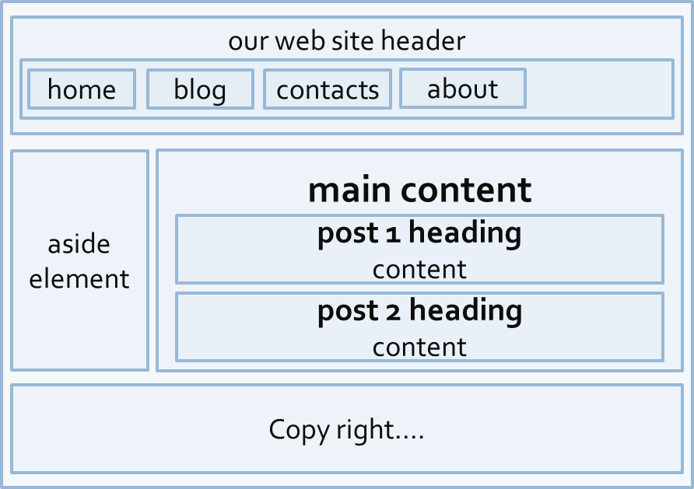](https://github.com/TelerikAcademy/HTML/blob/master/Topics/05.%20Semantic-HTML/imgs/pic22.png)

* This can be created using all kind of HTML elements
  + <div>, <span>, even <p>
  + Browsers will render invalid / wrong / pseudo valid HTML
* The correct way: use the HTML 5 semantic tags:

<header> … </header>

<nav> … </nav>

<main> … </main>

<article> … </article>

<section> … </section>

<aside> … </aside>

<footer> … </footer>

**HTML5 Structure Tags**

* <main>
  + Specifies the main content of a document ([info](http://html5doctor.com/the-main-element/))
  + There must not be more than one <main> element in a document
* <header>
  + Site header or section header or article header
  + Could include navigation (<nav>)
* <footer>
  + Site footer (sometime can be a section footer)
  + Providing author, copyright data, etc.

**HTML5 Structure Tags**

* <nav>
  + Defines a set of navigation links.
  + E.g. site navigation (usually in the header)
* <aside>
  + Content slightly related to primary content
  + E.g. sidebar (usually on the left or on the right)
* <section>
  + Grouping of content usually with a heading, similar to chapters
  + Site section (e.g. news, comments, links, …)

**HTML5 Content Tags**

* <article>
  + Independent content such as blog post or an article (e.g. news item)
* <details> + <summary>
  + Specifies additional details that the user can view or hide on demand (accordion-like widget)
* <time>
  + Specifies date / time (for a post / article / news)
* <mark>
  + Defines marked/highlighted text

**HTML5 Content Tags**

* <figure>
  + Grouping stand-alone content (video or image)
  + Figure (a figure, e.g. inside an article)
* <figcaption>
  + A caption of a figure (inside the <figure> tag)
* <video> ([info](http://www.w3schools.com/html/html5_video.asp))
  + Video element (uses the built-in player)
* <audio> ([info](http://www.w3schools.com/html/html5_audio.asp))
  + A standard for playing audio files (built-in player)

**HTML5 Content Tags**

* <dialog>
  + Defines a dialog box or window
* <meter> / <progress>
  + Defines a scalar measurement within a  
    known range (a gauge) or task progress
* <output>
  + Defines the result of a calculation
* <wbr>
  + Defines a possible line-break
* [More info](http://www.w3schools.com/html/html5_new_elements.asp)

**Other Semantics**

* Headings
  + Always use headings (<h1> – <h6>) when you need a heading or title
    - Like in a MS Word document
    - Google uses it to mark important content
* Strong <strong> vs. Bold <b>
  + <b> does not mean anything
    - It just makes the text bolder
  + <strong> marks the text is "stronger" than the other, surrounding text

**Other Semantics**

* Emphasis <em> vs. Italic <i>
  + Emphasis does not always mean, that the code should be italic
    - It could be bolder, italic and underlined
  + The styles for the emphasis text should be set with CSS
    - Not by HTML
* Old browsers (like IE6)?
  + Use [Modernizr](http://modernizr.com/) or [HTML5shiv](http://code.google.com/p/html5shiv/)

**Accessibility**

* Craft content minding disabled users
  + **Blind** - include text equivalents of images, use labels in forms
  + **Colorblind** - do not convey information using color only
  + **Visually impaired** - avoid small font sizes
  + **Epileptic** - avoid flashing content (3Hz or more)
  + **Physical disabilities** - avoid functionality that relies only on the mouse or keyboard

**Accessibility**

* Why implement accessibility?
  + Some accessibility features are mandatory for government sites in some countries (US, NL, SW)
  + “Everyone gets visited by a very important blind user, named Google”
  + Some SEO and accessibility considerations overlap

**Accessibility**

* Standards
  + Web Content Accessibility Guidelines (WCAG) - <http://www.w3.org/WAI/intro/wcag>
  + Section 508 - <http://www.section508.gov>
* Tools
  + Will never replace manual testing, but may help
  + WAVE - <http://wave.webaim.org/>

**Search Engine Optimization**

* Search engines use so-called “**crawlers**” to get the content of the page and index it
* The crawlers weigh the data on the page
  + <title>, **page URL** and **headings** have great weight
  + Links from highly valued pages to your page increase its value (Google **Page Rank**)
  + Add alt text to images
  + Use relevant keywords in the content and <meta> tags
* No SEO technique will replace good content

**Structured Data Markup**

* A standard way to annotate your content so machines can understand it
* Google (and other search engines) can
  + use that data to index your content better
  + present it more prominently in search results [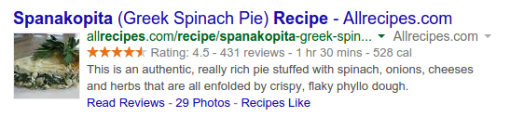](https://github.com/TelerikAcademy/HTML/blob/master/Topics/05.%20Semantic-HTML/imgs/pic31.png)
  + Provide answers from the Knowledge Graph

**Structured Data Markup**

* Three alternative formats:
  + Microdata and RDFa
    - Define new HTML attributes
      * [More info](http://schema.org/docs/gs.html#microdata_how)
  + JSON-LD
    - Newest and simplest markup format
    - Embed a block of JSON data inside a script tag
      * [Specification](http://www.w3.org/TR/json-ld/)
      * [*Examples*](http://json-ld.org/playground/)